Bainbridge WI NEWSLETTER
September 2020
President:
Susan Freer
‘Sheepscar’, Thornton Rust,
Leyburn, DL8 3AN
Telephone: 01969-663980
Email: susanfreer@btinternet.com

AUTUMN IS UPON US
It is amazing to think that we are already in September with the majority of the year over and done with – thank goodness! However, that means that we are lurching with alarming speed towards that big festival in December, which seems hard to believe. Hopefully, before that is upon us we might be lucky enough to enjoy an Indian Summer, although it isn’t looking promising at the moment!

REMEMBERING MARY
Before we can move on, it is only right that we stop to remember our dear friend, Mary Alderson, who died so suddenly on 11th August.

Mary had been a member of the WI for over fifty years, initially in Askrigg until its closure, and then Bainbridge. It is fair to say that Mary was an active member, in fact, she was active in whatever she did, and was rarely seen sitting around. Mary was a worker and loved to keep herself busy, volunteering for all manner of things. She had been on our Committee since 1979 which is quite some commitment, and had held the roles of Press Correspondent, Competitions Organiser, Raffle Organiser and more recently Organiser for trips, the Soup & Sweet lunches, the Lunch Club and the Seniors Christmas Lunch. She frequently attended the National and Federation AGM’s as our delegate and for many years was a key member of the catering section at the Great Yorkshire Show, where she would attend all three days, slaving away in the kitchen from early morning to early evening. Her job was to cut cakes into portions and according to Anne Harrison she was ‘a dab hand at it’! She often attended Denman, rarely missing a Federation visit, and was saddened to hear the recent news of its closure.

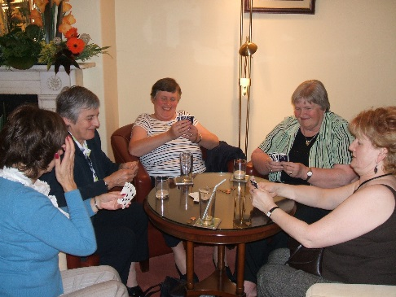
One of the things Mary will be remembered for was her love of travel and over the years she organized many wonderful holidays for WI members and others who joined them. They travelled from Bournemouth to Budapest and numerous other places around the world. A bit closer to home, she used to plan the trips and outings our members enjoyed and would often bring along coffee and cheese scones to sustain on the journey.
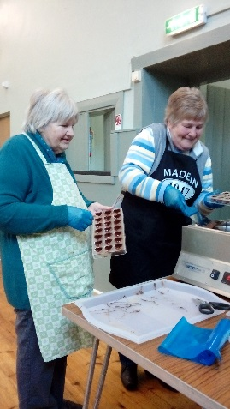
Mary was also a great crafter and attended many WI craft workshops, learning new skills and honing those she had already developed. She became a real expert at beading and for several years adorned a tree at St Oswald’s Church Christmas Tree Festival with her amazing beaded decorations.

We are all going to miss Mary enormously; she was a great presence in the WI (and the numerous other groups she was involved with), giving generously of her time and enthusiasm; she would help anyone and always preferred to be out and about enjoying herself than sitting at home. Of course, she didn’t tolerate fools gladly but it is hard to think of a time when she was not smiling, laughing or helping with something. We all have some wonderful memories of Mary to treasure and hopefully ease our grief but she leaves a big hole to fill in our lives. Perhaps her legacy should be that we all take a leaf out of her book and cram as much into our lives as we possibly can. May she rest in peace after a life well-lived and may her family find comfort in their happy memories of her.

CAKES AND PLANTS
On Saturday 29th August, we decided to try and hold a fundraising cake and plant stall on Bainbridge Village Green, in part to make up for losing our fundraising events this year but also as a good way to meet up outside. Unfortunately, the weather wasn’t quite what we had hoped for and we are convinced that Mary would have been laughing at us trying to put up the gazebo in gale force winds, with the help of Tim Prudden!

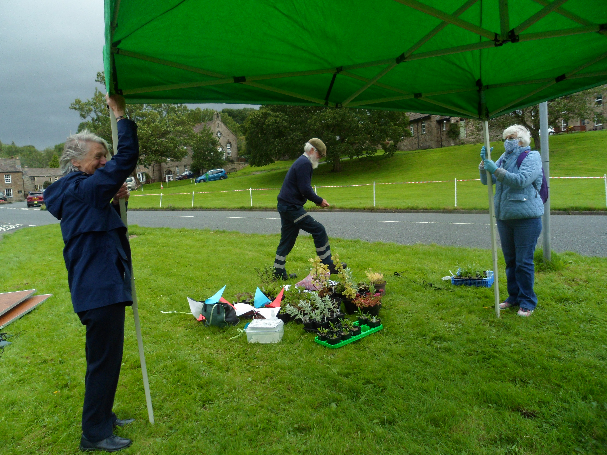
Eventually, we succeeded and set up our stall, but after a couple of hours of holding onto the gazebo poles for fear of it taking off in the wind, we gave in to the weather and packed up. However, by that time we had learned that there was to be a car boot sale on the green the following day so we booked a pitch there and were fortunate to enjoy much better weather. We managed to sell all the cakes, and some of the plants, raising £185.50, which is a great boost to our funds. Thanks must go to Susan, Gill, Margaret T, Janet and Karen for helping on the stall and to all those members who contributed cakes or plants to sell.

THE KENNEL FIELDS
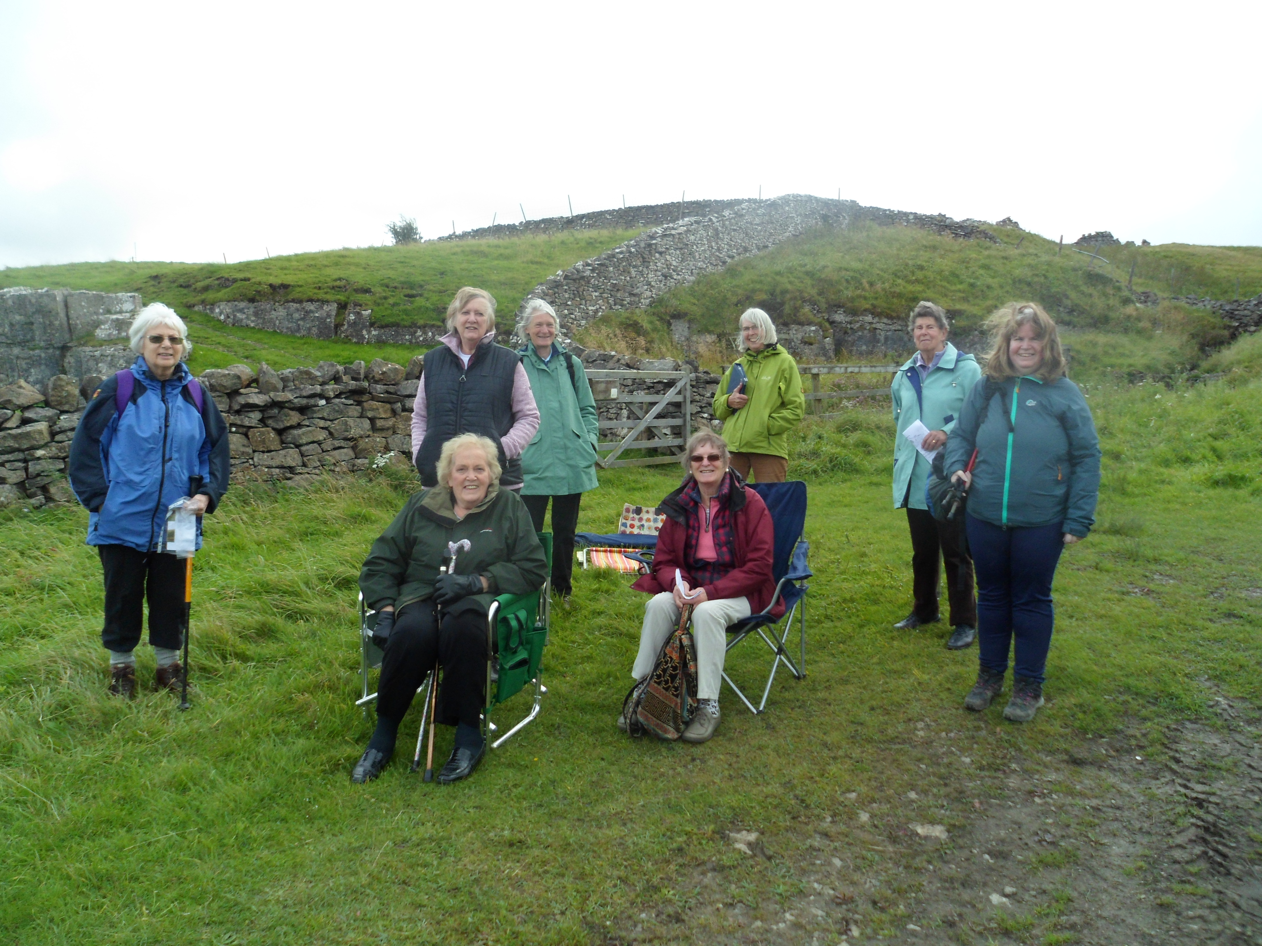
On 5th September we ventured out for another outside event at Thornton Rust Kennel Field. Yet again, the weather wasn’t very favourable but, nevertheless, eight members made the short walk from the village to the field where we enjoyed a talk by Deborah Millward telling us how the field was purchased in 2000 for the benefit of the village with the help of a grant from the Yorkshire Dales Millennium Trust. The field is a rich pasture where wildlife and landscape can be enjoyed by all. In the past, it was the home of the Wensleydale Harriers pack of hounds, and although the old kennels were removed, the Mash House was restored and we were able to see inside where the food was prepared for the hounds. Fortunately, we timed our visit to also allow us to shelter inside as a heavy rain shower passed over us!

Deborah also explained to us how the field is full of an amazing array of wildflowers and although she pointed out several to us, she recommended we return in late spring/early summer to enjoy them at their best. As the weather had deteriorated by the time Deborah had finished her talk, we took the wise decision not to venture off on a walk up Addlebrough - maybe another time!

FORTHCOMING EVENTS
Visit to Low Blean Alpaca’s – We thought it would be fun to go and see Jackie’s Alpaca’s at the farm at Semerwater; well, either fun or a total disaster! Anyway, we are booked to go on Saturday 12th September at 2.00 pm. If you would like to join us, please contact Susan as it is essential that we book so that Jackie knows how many to expect. Parking will be on the ‘beach’ (if there is one!) and you can bring your own chairs to sit on. Make sure you are well prepared for walking on the fields with boots and waterproof coats as we don’t anticipate glorious weather!

The Book Club is still running, albeit at some distance. That said, some members enjoyed a socially distanced meeting in Susan’s garden on a day when the weather was nice. If we are blessed with more days of nice weather, they may be able to meet again, but with winter getting closer the days of outside meetings are probably numbered.
Lunch Club will not resume again until next year (hopefully!) and we will be looking for a new organiser to take over the planning of dates and venues for us all to enjoy. We can’t wait to be able to get together again over some yummy food for a good natter!
Now that our own gardens are winding down for winter, the Garden Club is hoping to be able to visit some more established gardens, and begin with a visit to Thorp Perrow gardens on Saturday 10th October. We plan to meet in the car park at 11.00 am and this will be a visit for members and friends/family. Entry will cost £10.95 (£9.95 for concessions). The tea room will be opening but will only be serving takeaway food, so you could always bring your own. Mobility scooters can be hired in advance by calling 01677-427023. We hope you will join us.
The Craft Club will not be holding any physical sessions for the rest of this year, however Anne tells us that the Zoom sessions being organised by the Federation are well worth joining and cost £5 each.

THE FUN OF THE BOOK CLUB
The funny thing about being a member of the WI Book Club is that you do not need to read the suggested books. The great thing about it is that as all the members take it in turn to choose a title, you very often find yourself reading a different range of books. This for me makes life much more interesting and I enjoy discovering new authors. Pre-Pandemic we met every six weeks, usually at my house, but other members have very kindly hosted meetings which is great. The most important thing is that we have a great social evening. On arrival drinks are served and then we have a discussion about the books which we have read recently. The books are rated on a scale from one to ten where ten is the highest rating. We have a "bring and share" supper and enjoy chatting about a range of topics. Our last meeting was held in my garden. We were socially distanced and felt absolutely safe. We continue to suggest titles and there is a Bainbridge WI Book Club WhatsApp Group. Let's hope we will soon be able to resume our usual meetings and enjoy social time again. Susan

2021 DIARIES
It is time to order your WI diary for 2021. These will cost £5.10 but if you want one please make sure you contact Susan before the end of October so that an order can be placed.

BAINBRIDGE WI WEBSITE
If you have computer access, don’t forget to regularly check out our new website (www.bainbridgewi.com) where you will find information and photographs of our activities.

PROGRAMME 2021
Our programme for 2021 is now full and we really hope that we will be able to return to meeting up in the Village Hall on the third Thursday of the month from January. However, none of us really know if this will be possible, so in case it isn’t, we are still investigating …

VIRTUAL MEETINGS
We are contacting some of our speakers to see if they are able to give us their talk via this method in the future and we would like as many members to be involved as possible if this is our only option to ‘get together’. Don’t forget to get in touch with Susan, or indeed any Committee member, if you are interested in getting help to join in future ‘virtual’ meetings of the WI. If you have a computer or iPad it is quite easy to join our Zoom meetings and you won’t even have to leave your comfy armchair.

FEDERATION NEWSLETTERS
You may not know that we have to pay for copies of the Federation Newsletter for our members, but this is the case and we are now wondering just how much our members value this publication. We would like to survey you all to see if you wish to continue to receive a copy of the Federation Newsletter or if you find it of very little interest to you. We intend to continue issuing our own monthly Newsletters and can detail Federation matters which we believe are important to members via this. Please let committee members know your views before we need to renew our subscription for next year.

LOOKING AHEAD
Obviously, life is still very different to what we are used to and the situation remains fluid which is making any form of planning extremely difficult. That said, we have contacted our October speakers to enquire if they could do their talk via Zoom, and they have agreed. So, on Thursday 15th October at 7.00 pm, Professor Charlotte Roberts and Chris Gerrard will talk to us about The Scottish Soldiers Project. This should last no more than an hour and we hope it will be very interesting. Make sure that you contact a member of the committee if you want to take part so that you can be sent the link to join the meeting.

On Thursday 19th November, we intend holding our AGM via Zoom, starting at 7.00 pm. Copies of the annual reports will be issued to members prior to this meeting and if you have any queries or comments to make, please let Susan know before 19th November. After the business of the meeting has been done, we plan to hold a quiz, which should make for a fun evening. Again, please get in touch to let us know if you wish to join so that you can be sent the link.

We are having slightly more difficulty in finding out whether we will be able to hold our Christmas Party this year. Some venues seem to think not, whilst others are happy to take our booking. It seems the guidance is very unclear so we intend to make some further enquiries and will let you know the outcome in due course. Whatever happens, it is likely that the format of the Christmas Party will be different to previous years, but it would be nice to think that we could all get together somehow. Watch this space for more news!

Meanwhile, your committee members are still meeting ‘virtually’ on a monthly basis and hoping that you are all keeping safe and well. We have all had to adapt our lives to the ‘new normal’ and we know that for many this still means a degree of isolation. Please let us know if you need any help, or someone to talk to, by contacting Susan in the first instance. YOU ARE NOT ALONE WITH THE WI!

With every best wish from your President and members of the Committee.

TAKE CARE AND STAY SAFE!

TIME FOR SOME QUIZZING, AND THIS MONTH IT IS ON SCIENCE AND NATURE
GOOD LUCK!

- Jupiter is the largest planet in our solar system. What is the second?
- What is the medical name for the two bones in the lower arm?
- What does the letter ‘V’ stand for in DVD?
- What is the UK’s largest carnivorous animal?
- What is the correct spelling for the compound that gives leaves their green colour?
- What name is given to the study of the path taken by projectiles, such as bullets and rockets?
- What is a male swan called?
- What is the more common name for Sodium Chloride?
- In Roman Numerals, what is XV?
- What is the name of the unit of heat required to raise one gram of water one degree centigrade?

Answers to Last Month’s Quiz:-

- Eight. George, Charlotte, Louis, Archie, Savannah, Isla, Mia and Lena
- ‘Candle in the Wind 97’ by Elton John
- Balaclava
- Alexander Borodin
- Matthew
- St Helena
- Tony Robinson
- A Clown
- 15th July
- Prince Albert
- Sir John Betjeman
- Hydrofoil
- Croatia
- Julius Caesar
- Herman Melville
- Japan
- A Monkey
- Jane Seymour

So, how did you do this month?

